INTRODUCTION:

This year I am planning to upload my currency collection on internet for a world record inspection. I want to put my collection on bid sale after that.

This will benefit me to collect some money from my collection, which I can further use for Masters studies. Also, the end user ,that is , both the Guinness and the buyer would benefit as he would get to the collection with the actual image. There will be an introduction/about page in my project from where people can know more about my project.

I am going to include images from my collection as well as resources. It means that it will contain both local image uploading as well the use of anchor tags. Further, I will be using the anchor tags to link the website like numista to help my user get more information about the collection.

UI DESIGN:

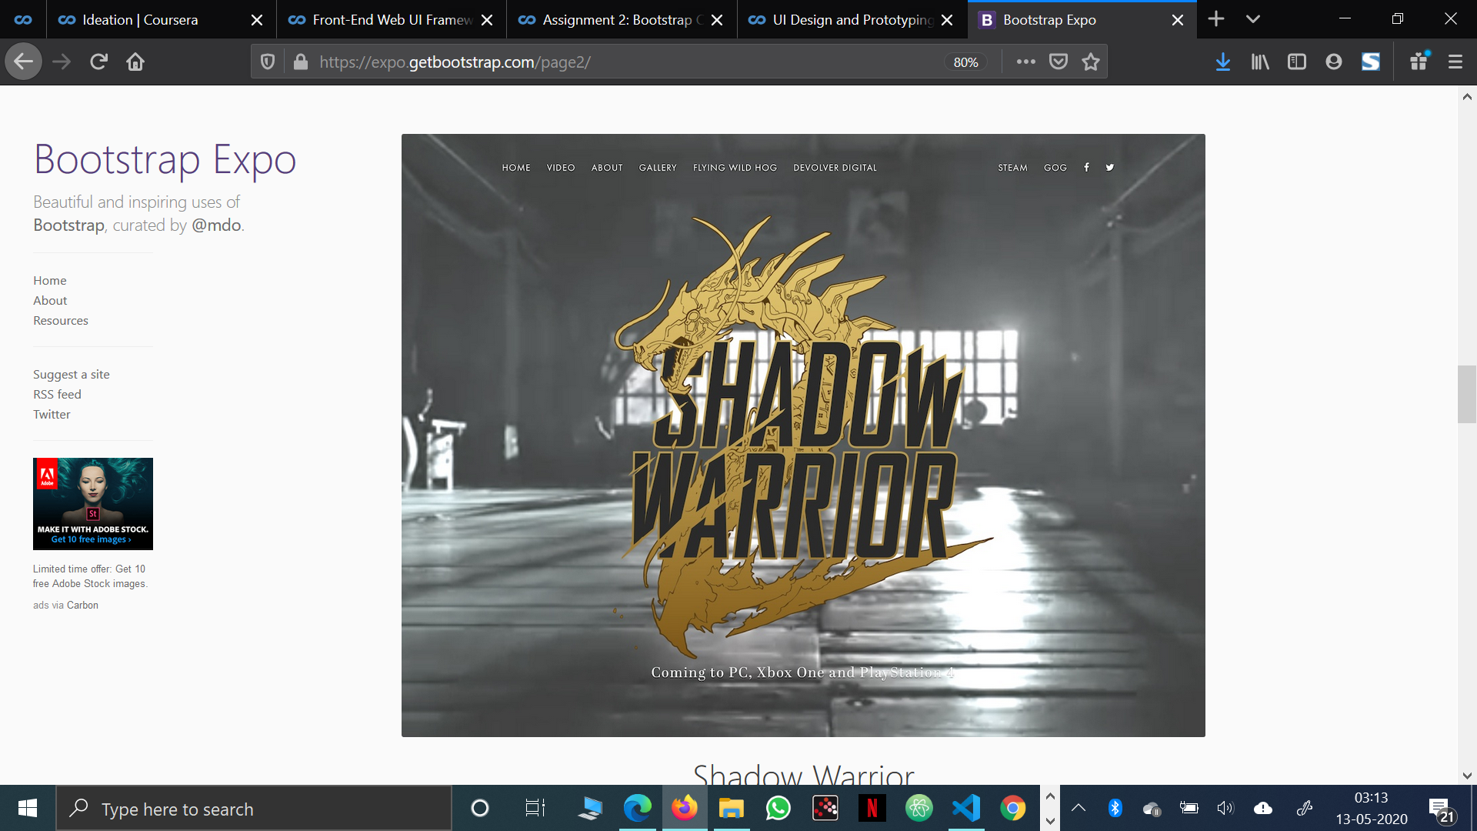

This is the UI design which I’m personally planning to use for my website.

The Reasons:-

* My navbar is going to include About, Home, Buy, Collection, Contact, etc. due to which a navbar would look great in the above UI.
* Also, I am planning to put a watermark of my album on the first page by which I can use this UI to do so.

NAVIGATION STRUCTURE:-

The key reason for creating the prototype is to get feedback from stakeholders and users to make sure it is going in the right direction. It allows you to fix any areas which receive negative feedback, and it allows for discussion about what is really needed in the final build and what could be removed. This can save a huge amount of money in development later on in the project.

MY PLANNED PROTOTYPE (IT WILL CHANGE DURING THE DESIGNING):

HOME >>GALLERY>>INFO>>NUMISTA>>COLLECTION>>ABOUT

HOME>>WHAT I PLAN TO WITH THE WEBSITE

GALLERY>> A GLANCE AT MY COLLECTION

INFO>>SELECT THE COIN TO GET THE INFO

NUMISTA>>A DIRECT LINK TO en.numista.com

ABOUT>> MY CHILDHOOD WITH COINS AND HOW I GATHERED IT

COLLECTION>> A COMPLETE TABULAR FORM OF MY LIST

REFERENCES:-

1. <https://www.feedspot.com/infiniterss.php?_src=feed_title&followfeedid=1425126&q=site:https%3A%2F%2Fcoinweek.com%2Ffeed%2F>
2. <https://www.feedspot.com/infiniterss.php?_src=feed_title&followfeedid=1425136&q=site:https%3A%2F%2Fwww.numismaticnews.net%2Ffeed>
3. <https://www.feedspot.com/infiniterss.php?_src=feed_title&followfeedid=4641647&q=site:http%3A%2F%2Fnews.coinupdate.com%2Ffeed%2F>
4. <https://www.feedspot.com/infiniterss.php?_src=feed_title&followfeedid=4643354&q=site:http%3A%2F%2Fblog.perthmint.com.au%2Ffeed%2F>
5. <https://www.feedspot.com/infiniterss.php?_src=feed_title&followfeedid=4643327&q=site:http%3A%2F%2Fnumismatics.org%2Fpocketchange%2Ffeed%2F>